Title of your paper

First Author · Second Author · Third Author · Last Author

**Abstract** The abstract should summarize the content of the paper, indicating its aim, starting point, original contribution and conclusions (up to 200 words).

1. Introduction

This document briefly describes how to write a manuscript for ELECTRIMACS 2024 Castelló conference.

1. How to prepare your paper
   1. Templates

Authors are kindly invited to prepare a manuscript according to the LATEX or Word template available on the conference website:

<https://electrimacs2024.uji.es/>.

The use of LaTeX is *highly recommended* for manuscript preparation.

This is the template version 1.0 – May 2023.

* 1. Manuscript information

Authors are kindly asked to prepare their manuscript according to the following specifications:

* Language: English
* Size: A4
* Two columns
* Length: from four (4) to six (6) pages.

* 1. Document style and size

F. Author · T. Author

DESID – Universitat Jaume I

Av. Vicent Sos Baynat, s/n 12071 Castell\'on de la Plana, Spain

e-mail: fauthor@somewhere.org, tauthor@elsewhere.com

S. Author · L. Author

Institution name

address line 1

address line 2, if needed

Zip code, City, Province, Country

e-mail: ...

The document margin and column size are summarised in Tab. 1. Font, style and size of titles and texts are reported in Tab. 2.

**Table 1** Columns and margins

|  |  |
| --- | --- |
| **Parameter** | **Value** |
| Left margin | 15 mm |
| Right margin | 21 mm |
| Upper margin | 30 mm |
| Lower margin | 31 mm |
| First page upper margin | 47 mm |
| Blank space after author’s line | 43 mm |
| Column width | 84 mm |
| Column separation | 6 mm |
| Figure width | ≤84 mm |

* 1. Submission of papers

A camera-ready PDF manuscript must be submitted for review through the conference submission system. No other file format is accepted for this initial submission. You will find more information about initial submission on the conference website *Papers > Submission*.

**Table 2** Document Style

|  |  |
| --- | --- |
| **Style** | **Characteristics** |
| Paper Title | 16 pt, bold, left-aligned |
| Author’s names | 10 pt, bold, left-aligned |
| Affiliation and e-mail | 8.5 pt, left-aligned in the  footnote in column one |
| Section title | 10 pt, bold, left-aligned, hierarchically numbered |
| Subsection title | 10 pt, italic, left-aligned, hierarchically numbered |
| Main body text | 10 pt, justified, single-spaced |
| Acknowledgements section title | 8.5 pt, bold |
| Acknowledgements body text | 8.5 pt, justified |
| Figure and table title | 8.5 pt, bold |
| Figure and table captions | 8.5 pt, justified |

* 1. Figure, tables, citations and cross reference

C:\Users\walte\AppData\Local\Microsoft\Windows\INetCache\Content.Word\graph1.tif

**Fig. 1** Please write the caption here. If the caption is long, the text of the caption is justified.

Refer to a figure using Fig. 1, or Fig. 2. Refer to a table using Tab. 1. You can cite an item listed in the Reference section as [1] or [2,3].

* 1. Equations

Equations are left-aligned and numbered as shown below:

|  |  |
| --- | --- |
| $$\left(\frac{R_{e}}{1-D}+\frac{{DT}_{s}}{C_{e}}\right)≤∆v_{pp}^{max}.$$ | (1) |

Please refer to an equation using (1).

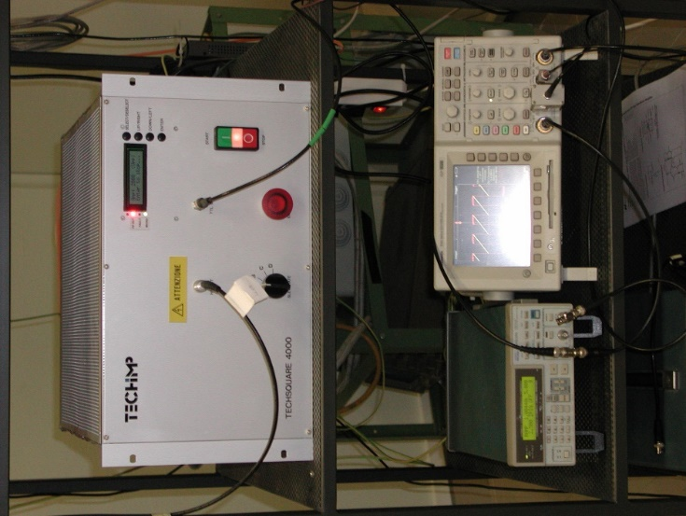

**Fig. 2** Experimental setup

1. Section title

ELECTRIMACS 2024 is an international conference on theory and application of modelling, simulation, analysis, design optimization, identification and diagnostics in electrical power engineering.

* 1. Subsection title

Application of interest include, but are not limited to:

* electric machines and electromagnetic devices
* power electronics
* transportation systems
* smart grids
* electric and hybrid vehicles
* renewable energy systems
* energy storage, batteries, supercapacitors and fuel cells
* wireless power transfer

1. ELECTRIMACS 2024 Topics
   1. Modelling, Simulation and Identification

* Diagnostics in electrical systems
* Modelling methods and software development
* Modelling and simulation of power systems, power electronics and drives, distributed generating systems, electric machines and transformers, batteries and fuel cell systems
* Electromagnetic fields and compatibility
* Emerging electrical technologies
* Simulation methodologies for design and analysis of electromagnetic devices
* Hardware in the loop emulation
* Thermal problems
  1. Systems’ Design and Optimization
* System identification and optimization methods and theory
* Computer-aided design and optimization of power converters, protections, energy storage systems, electric machines, power systems
* Multiphysics issues
* Power system and power converter architectures
* Methods and techniques for energy management
  1. Control and Power Management
* Optimal, feedback, and stochastic control
* Filtering
* Linear and nonlinear systems control and programming
* Digital implementation and control applied to electrical systems
* Real time simulation methods
* Rapid control prototyping of electrical systems
* Embedded systems
* Fuzzy logic and applications
* Genetic algorithms and evolutionary computing
* Model predictive, robust, sliding mode networked control of electrical systems and machines
* Identification/diagnostic/prognostic techniques applied to electrical systems
* Power quality
  1. Numerical Methods and Machine Learning
* Artificial intelligence’s potential to boost electrical systems performance
* Grid condition monitoring and predictive maintenance
* Electrical market variables pattern recognition
* Energy storage systems degradation analysis
* Renewable energy generation and electric demand forecast
* Applications in electric vehicles
* Estimation of state-of-charge and state-of-health in batteries; signal modelling
* Robot locomotion
* Electrical systems’ parameter identification
* Energy flows prediction
* Electrical faults forecasting

1. Conclusions

Write your conclusions here.

Acknowledgements You can write your acknowledgements here, if necessary.

References

1. W. Teulings, J.L. Schanen, J. Roudet, “Analysis of the Current Dis­tribution Between Paralleled Capacitors in a Chopper on Printed Circuit Board”,*IEEE Industry Applications Society Annual Meeting New Orleans*,pp. 1066-72, 1997.
2. S. Maniktala, *Switching Power Supplies A to Z* – Second Edition, Waltham, 2012.
3. R. Cousseau and N. Patin and C. Forgez and E. Monmasson and L. Idkhajine,“Improved electrical model of aluminium electrolytic capacitor with anomalous diffusion for health monitoring”, *Mathematics and Computers in Simulation*, Vol. 131, pp. 268–282, 2017